COMP 1805 B1

Michael Maxwell

101006277

april 7, 2016

5

1. Base Case: n = 2, $\sum_{i=1}^{n}{\frac{3}{4^{i}}}$ = 3 $\sum_{i=1}^{n}{\frac{1}{4^{-i}}}$ =   
   Hypothesis:   
   Induction:
   1. Base Case: n = 0,   
      Hypothesis:  
      Induction:
   2. Base Case: n = 1,   
      Hypothesis:  
      Induction:
2. Base Case: w = 12,   
   Hypothesis:  
   Induction:
   1. an = 3n – 1
   2. an = 17
   3. an = + 2n
   4. Reflexive, Anti-Symmetric, Transitive, Partial Order

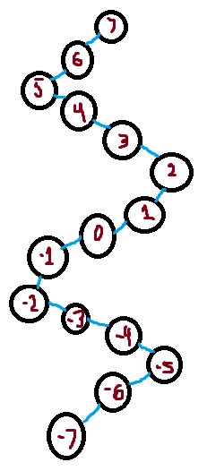

* 1. Reflexive, Symmetric, Anti-Symmetric,
  2. e, a, u
  3. h
  4. No
  5. Yes
  6. None
  7. h, f, p, j
  8. f
  9. c
  10. h

1. h p j b o g n f m k r s t l c e i d a u